Summer reading challenge
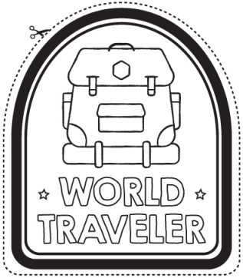 | 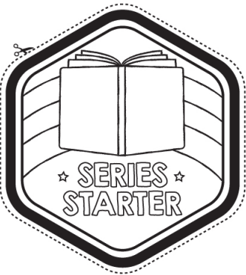 | 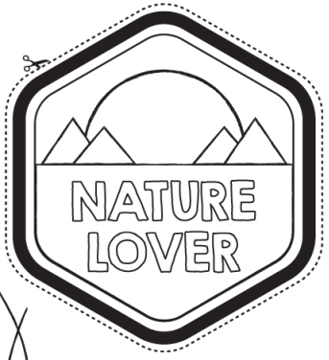 | 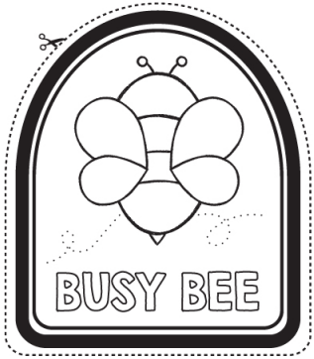
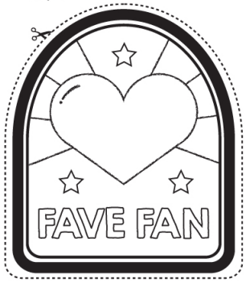 | 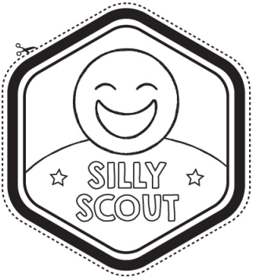 | 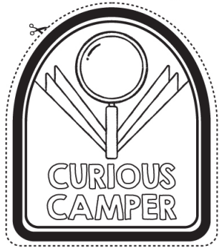 | 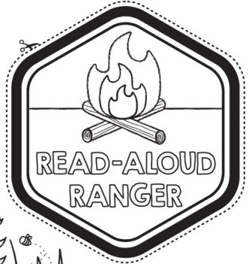
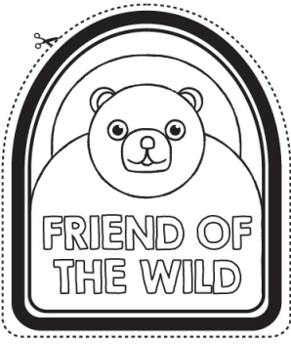 | 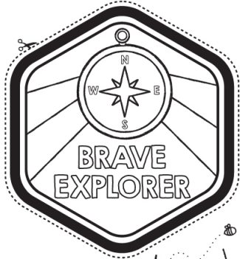 | Draw your own badge  Explain what you did to earn this badge | Draw your own badge  Explain what you did to earn this badge

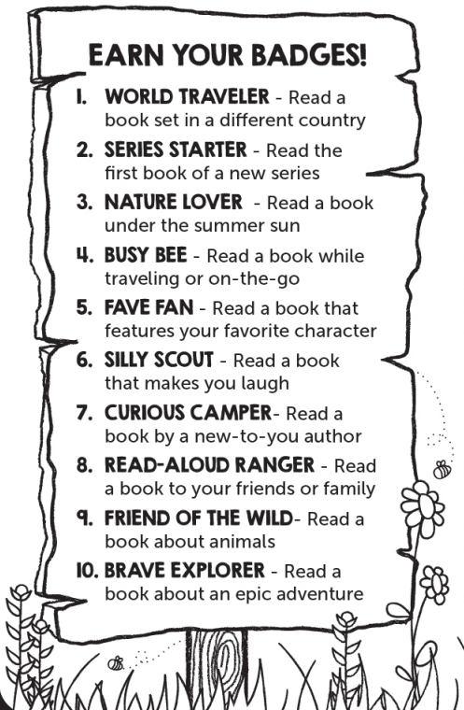
This summer, dive into books, soak up stories, and have tons of fun!
Earn badges as you read awesome books. Once you’ve checked off 10 badges, bring this challenge page back to Mrs. Truscott when school starts, and you’ll get to pick a cool prize from the prize box!
Bonus: Everyone who brings back their challenge will be entered to win a copy of the Guinness Book of World Records!
Have a blast—and happy reading!

11. ______________________________(name of badge)
______________________________________________
______________________________________________
(what did you do to earn this badge)
12.______________________________(name of badge)
______________________________________________
______________________________________________
(what did you do to earn this badge)

