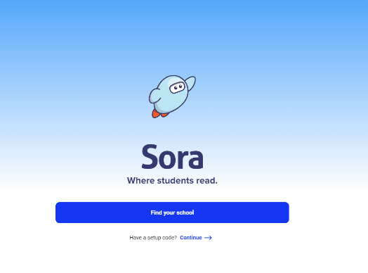
2
1
Click ‘Find your school’

4
3

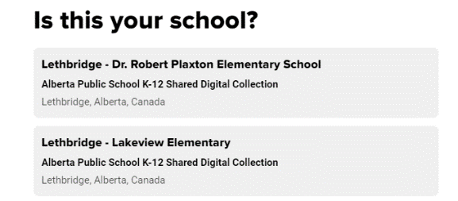

Click on ‘Lethbridge – Lakeview Elementary’ from the list of schools

5
Click ‘sign in using Lethbridge School district No. 51’. Use your school email and log in information.
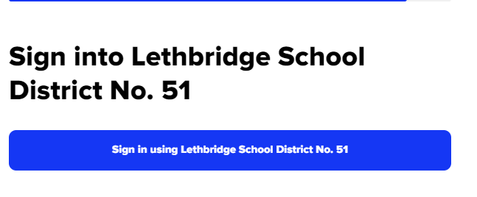

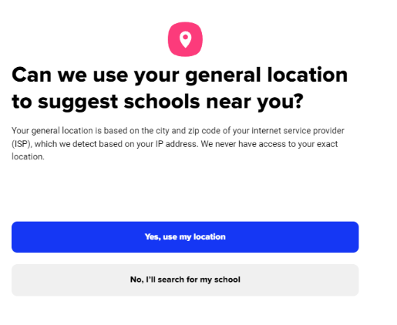
Click ‘Yes, use my location’
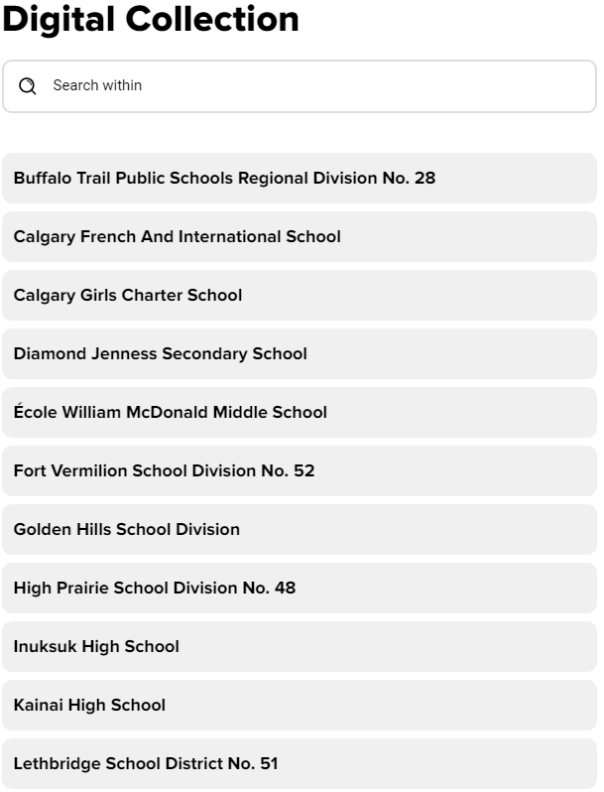
Click on ‘Lethbridge – Lakeview Elementary’ from the list of schools

